MACH4METAL

metalworking machinery
Transito 21
6909 DA BABBERICH Netherlands
Tel. +31 (0)316-247123
Fax: +31 (0)316-247956
info@mach4metal.com
www.mach4metal.com

Bank No : 66.52.13.883
IBAN : NL33 INGB 0665 2138 83
BIC : INGBNL2A

ROUNDO Dishing& Flanging
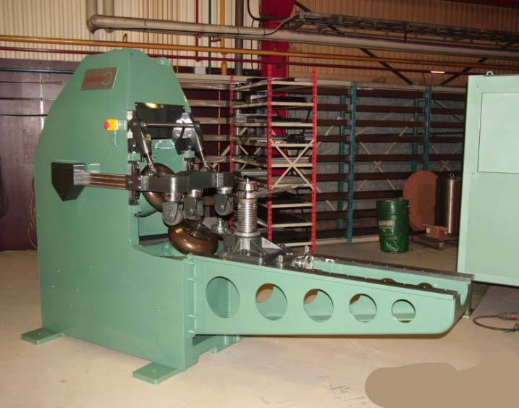
- Make : ROUNDO
- Typ : F 13 C
- Age : 20..

- Max. thickness 40 kg/mm² : 13
- Max. thickness 60 kg/mm² : 10

- Max. dishing radius : 75
- Max. height on dishing side : 40

- Max. blank / Workpiece Ø : 3.000
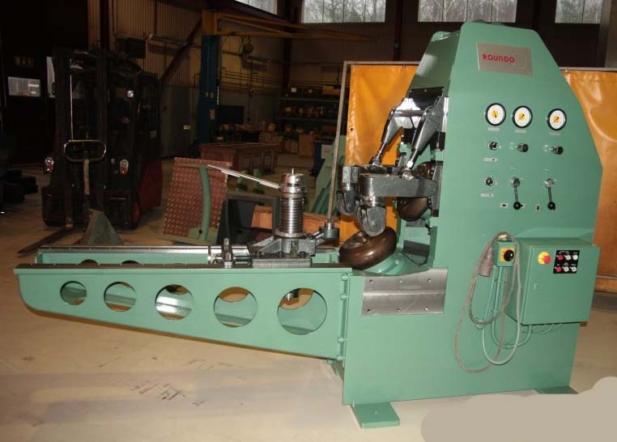
- Min. blank / Workpiece Ø : 800
- blank with special tool & 6 mm : 535

Dimensions
- Length : 2.875
- Width : 990
- Height : 2.010
- Weight : 2.000
- Power : 7.5 Ps

- Optional tooling R 30 / 50 / 75 / 90 / 100
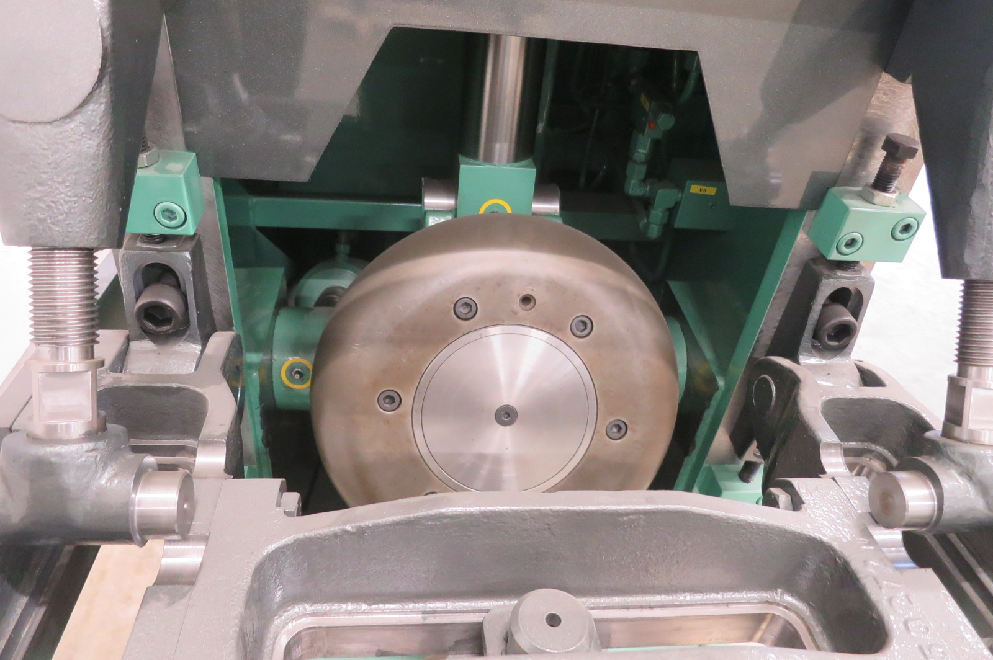

- Incl. set tooling wheels
- Incl. steady rolls
- Incl. documentation

Field of application of the machine:

Field off application of the machine; Tank ends, silo tunnels, fume hoods, rocket and prime mover components, large containers and flanged & profiled parts for tanks, vessels for the chemical and the aircraft industry.

Please Note: The above information has been obtained to the best of our ability and belief from, and from the manufacturers where possible. It is given in good faith, but its accuracy can not be guaranteed. Accordingly, it will not form a representation or constitute contractual terms. We advise you to check any vital details!

